|  |  |
| --- | --- |
| **Network Infrastructure**  Diploma in CSF / IT  Year 2 (April 2022) Semester 3 | Week 03 |
| Tutorial |
| IP Routing (Static Routing) | |

**OBJECTIVES**

After completing this session, you should understand the concepts of routing and static routing.

**Activity 1**

1. How does the network layer forward packets from the source to the destination?
   1. by using ARP responses
   2. by using an IP routing table
   3. by referring to a name server
   4. by referring to the MAC address table (switch table)

Ans: b. by using an IP routing table

1. ________ is a network with one path to a router.
   1. Static network
   2. Dynamic network
   3. Local area network
   4. Stub network

Ans: Stub netwrok

1. Which best describes a default route in the routing table of a router?
   1. urgent-data route manually entered by a network administrator
   2. route used when part of the network fails
   3. route used when destination network is not listed explicitly in the routing table
   4. preset shortest path

Ans: c.

1. What role does the network ID play in an IP address?
   1. it specifies which networks the device can communicate with
   2. it specifies which node on the subnetwork is being addressed.
   3. It specifies the identity of the computer on the network
   4. It specifies the network to which the host belongs

Ans: d

1. Routers use _________________ to forward traffic through a network.
   1. IP address
   2. IP address and MAC address
   3. host address and MAC address
   4. MAC address

Ans: a

1. In order to automatically build a routing table, the router must use
   1. static routing
   2. default routing
   3. stub routing
   4. dynamic routing

Ans: d

1. Which of the following statements best represent the advantage of a static route?
   1. better control
   2. flexibility
   3. ease of management
   4. manual entry

Ans: a

1. The router must read the ___________ in the IP header to decide where to direct an incoming packet.
   1. source address
   2. destination address
   3. flags
   4. TTL

Ans: b

1. Which IP header field is used to control packets that might otherwise loop endlessly through a network?
   1. source address
   2. destination address
   3. flags
   4. TTL

Ans: d

**Activity 2: Routing**

1. What is the function of a router? Compare the function of a router with a switch.

|  |
| --- |
| A route is a multi-port internetworking device that interconnects 2 or more networks. It performs “forwarding and filtering” of data packets between these networks at the network layer. A router routes packets from one network to another network until it reaches its destination based on the destination IP address or if its TTL reaches 0.  A route makes decisions based on the destination IP address of a packet unlike a switch that uses a MAC address in a data frame to perform switching. |

1. Describe the advantages of using a router.

|  |
| --- |
| 1. Separates network logically into subnets; reduces network traffic as packets are only routed to their destination subnet 2. Isolates MAC broadcasts as it does not forward broadcast frames. 3. Connects different protocols: LAN protocols (e.g., Ethernet MAC) and WAN protocols (e.g., PPP). |

1. How does a router create entries in its routing table? What is the typical information in the routing table? Briefly explain how a router makes routing decisions using its routing table.

|  |
| --- |
| Routing table entries can be created either by static or dynamic routing.  During dynamic routing, routing table entries are filled by the protocol used e.g., RIP, OSPF.  During static routing, network administrator configures the route in the router, the router then adds the route in its routing table and lastly, the packets are forwarded based on the static entries in the routing table.  Routing tables typically store the location of routes based on their IP addresses and contains information such as network destination, netmask, gateway, interface, metric. Contains information about various networks and how to get to them.  The router sees the network destination for the packet and check its routing table to see if the network destination is already in it. If it is, it uses the path in the table to forward the packet. If it isn’t, it uses the default route to forward the packet. Also, if there exists two ways to forward a packet, the router will use the optimal way which will be based on the metrics chosen (n.a for static routing). |

1. Based on Figure 1 below, explain how a data packet is routed from PC A to PC B.

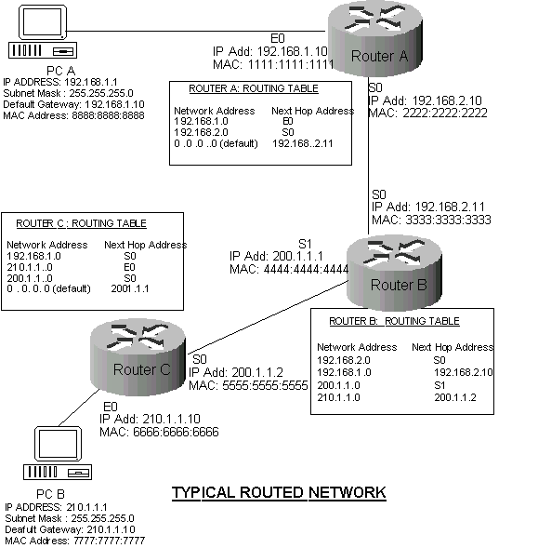

**Figure 1:** Routing in a typical network

|  |
| --- |
| The data packet from PC A will be forwarded to Router A. Router A will then forward the packet to router B using Router B network ID in its routing table. Router B will do the same and forward the packet to router C based on router’s C network ID in its routing table. Lastly, Router C will forward the data packet to PC B via a switch which uses MAC address to identify hosts. |

**Activity 3: Static Routing**

1. Give two advantages and one disadvantage of static routes.

|  |
| --- |
| 1. Better security compared to dynamic routing 2. Good for small networks as you have better control   However,   1. Any changes in the network means all routers must be updated to reflect the change. |

2. Figure 2 below shows a typical corporate network with 4 routers. To reduce routing overheads, the network administrator decided to use static routing.

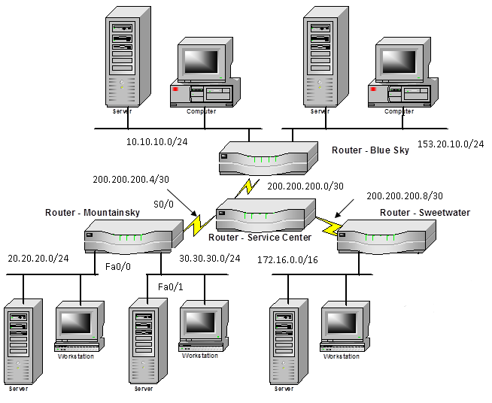

Figure 2: Typical corporate network

a) Write down the commands to configure the Mountainsky router with the IP addresses of all its interfaces. All the Mountainsky router interfaces are assigned the first usable address of their subnets.

|  |
| --- |
| Mountainsky(config-if)# interface s0/0  Mountainsky(config-if)# ip address 200.200.200.4 255.255.255.0  Mountainsky(config)# no shutdown  Mountainsky(config-if)# interface fa0/0  Mountainsky(config-if)# ip address 20.20.20.1 255.255.255.0  Mountainsky(config-if)# no shutdown  Mountainsky(config-if)# interface fa0/1  Mountainsky(config-if)# ip address 30.30.30.1 255.255.255.0  Mountainsky(config-if)# no shutdown |

b) Write down the commands to configure the Mountainsky router to create a static route for each of the remote network in the company. The IP address of the next hop router is 200.200.200.6.

|  |
| --- |
| Method 1: Using out-going Interface  Mountainsky(config)# ip route 200.200.200.0 255.255.255.0 s0/0  Mountainsky(config)# ip route 200.200.200.8 255.255.255.0 s0/0  Mountainsky(config)# ip route 10.10.10.0 255.255.255.0 s0/0  Mountainsky(config)# ip route 153.20.10.0 255.255.255.0 s0/0  Mountainsky(config)# ip route 172.16.0.0 255.255.0 s0/0  Method 2: Using the Next Hop Address  Mountainsky(config)# ip route 200.200.200.0 255.255.255.0 200.200.200.6  Mountainsky(config)# ip route 200.200.200.8 255.255.255.0 200.200.200.6  Mountainsky(config)# ip route 10.10.10.0 255.255.255.0 200.200.200.6  Mountainsky(config)# ip route 153.20.10.0 255.255.255.0 200.200.200.6  Mountainsky(config)# ip route 172.16.0.0 255.255.0 200.200.200.6 |

c) Since Mountainsky router is part of a stub network, write down the one command required to configure the Mountainsky router to enable the 20.20.20.0/24 and the 30.30.30.0/24 networks to reach all the networks in the company. The IP address of the next hop router is 200.200.200.6.

|  |
| --- |
| Mountainsky(config)# ip route 0.0.0.0 0.0.0.0 200.200.200.6 |

d) Write down one command required to configure the Service Center router to enable the 20.20.20.0/24 network to be reachable by all the networks in the company. The IP address of the Mountainsky router is 200.200.200.5.

|  |
| --- |
| Service Centre(config)# ip route 20.20.20.0 255.255.255.0 200.200.200.5 |